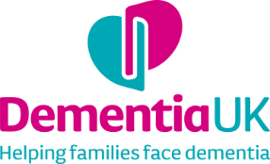
Learning Disabilities Admiral Nurse service – Supporting People with a Learning Disability and Dementia

A funding report to The Burdett Trust for Nursing

We were very grateful to the trustees of the Burdett Trust for Nursing for their very generous donation in 2019 of £73,741 towards the Learning Disabilities Admiral Nurse service hosted by MacIntyre. I am delighted to write to you with a final report, outlining the impact which this pilot service has had.

Background to the role
One in ten people with learning disabilities will develop dementia and do so at a younger age than people without learning disabilities. People with Down’s Syndrome are more likely than people with other types of learning disability to develop dementia, with prevalence increasing with age. One in 50 people with learning disabilities aged 30-39 will develop dementia, rising to one in ten aged 40-49 and one in three in their 50s.

MacIntyre is a nationwide charity for adults and children with learning disabilities. Founded in 1966, MacIntyre provides a wide range of services to adults with learning disabilities and/or autism in 16 counties, including supported living, day opportunities, and employment support. Ten years ago, MacIntyre become more aware of the effects of ageing on people being supported by the charity and the risks of dementia in people with learning disabilities. At the same time staff felt they lacked the knowledge or training to support people.

A dementia special interest group was formed, but as all members worked full-time they weren’t able to focus fully on dementia and learning disability. MacIntyre developed a successful work stream around dementia, which led to the development of a relationship with Dementia UK. In 2019 Dementia UK was successful in securing support from the Will Charitable Trust and The Burdett Trust to support the first UK Learning Disabilities Admiral Nurse (LDAN) service, hosted by MacIntyre.

Setting up the Learning Disability Admiral Nurse service
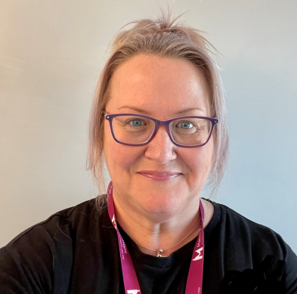
Jane Nickels came into post in May 2020. Jane has 30 years of experience in the care sector and over 12 years of experience as a RNLD (Learning Disability Nurse). The focus initially was on establishing the role within MacIntyre and putting into place the infrastructure to support the implementation and monitoring and evaluation of the service.

Four logic models were developed to provide a structure for the LDAN service. Logic models are designed to act as ‘road maps’ for services or projects, enabling stakeholders to work together to define a situation or problem that needs addressing and what the changes and improvements would look like (these are appended at the end of this report):
- Logic model 1 - Circles of support
- Logic model 2 - Working collaboratively
- Logic model 3 - Clinical leadership
- Logic model 4 - Promoting health and prevention education

A referral process for the service was developed along with a needs assessment tool designed to meet the needs of people with a wide range of different learning disabilities. Jane has chaired the Admiral Nurse Steering Group, which meets every two months. Another key initial step was an evaluation of MacIntyre’s “Needs Analysis” database to identify which people are in the circle of support of individuals known by MacIntyre to have dementia and a learning disability. This informed the development of the referral criteria for the service and provided a framework for the development of a strategy to meet the needs of and support a large number of individuals nationally.

Outputs

1. Support for people with learning disabilities and dementia
The LDAN has held a small caseload of individuals with learning disabilities either already diagnosed with dementia or where it is observed that the person is experiencing memory problems and is at risk of dementia. Between July 2020 and February 2022, a total of 107 people had been on the caseload of the LDAN. The monthly average number of people held on caseload was between 5 and 6. We monitored the number of “contacts” (instances of support which the LDAN provided to people with learning disabilities and dementia) who were on the caseload over this time:

- Between August 2020 and February 2022 there were 3,305 contacts by Jane with individuals with learning disabilities and dementia - an average of 174 contacts per month.
- 97% of consultations and other forms of contacts took place remotely. Consultation via email or text (2,989, 90% of total) was the most common method for conducting consultations.
- 45 consultations (1%) were conducted face-to-face, with most from May 2021 after the pandemic restrictions were eased. Face-to-face consultation could be anywhere in the UK where MacIntyre is supporting adults with learning disabilities. As significant travel distances were often required for face-to-face consultation, remote support continued to be the most efficient and effective form of support following the easing of restrictions.

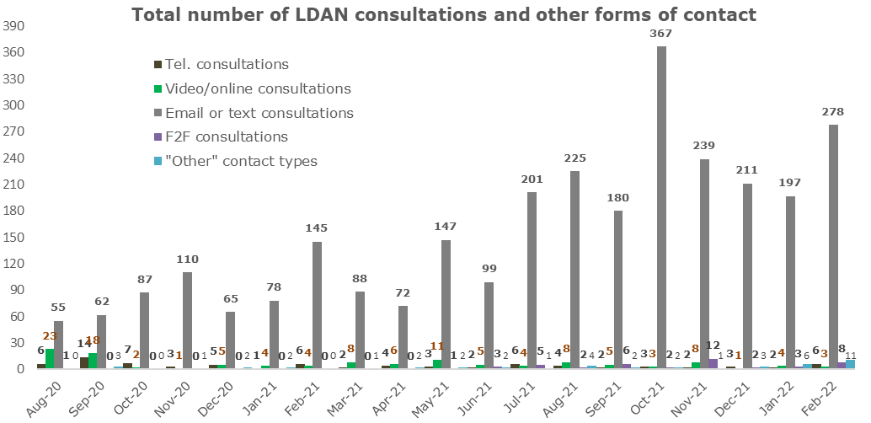

2. Education to support best practice
Jane delivered a series of 16 webinars for MacIntyre staff, focusing on the following areas:

1. What is dementia?
2. Dementia: A timely diagnosis
3. Dementia and Sleep/Sundowning
4. Dementia: Changes in Behaviour
5. Dementia Friendly Environments
6. Dementia and Physical Wellbeing
7. Dementia and Emotional Wellbeing
8. Dementia and Relationships
9. Dementia and Life stories
10. Dementia: Promoting a Good Life
11. Dementia Friendly Activity
12. Dementia: Planning for the future
13. Dementia: MCA Best Practice/ Best Interest Decisions
14. Dementia and Epilepsy
15. Dementia: Meal Times
16. Dementia: Reality Orientation & Validation

Around 110 participants attended these webinars. Every webinar was followed by an hour drop-in session, where staff could ask specific questions about the people they support and learn different ways they can engage with that person more. Jane has been able to discuss life-story work, the diagnosis process, and has sign-posted to resources to give staff the confidence to continue supporting the person.

In addition to these webinars, Jane has facilitated a number of face-to-face dementia training sessions and attended and supported 14 virtual memory cafes. Jane also leads on or supports four special interest groups within MacIntyre focusing on dementia, autism, health, and positive behaviour support.

3. Dissemination
Jane has carried out a wide range of activities with the goal of ensuring that the learning we gain through the service has a wider impact beyond the initial two years of the service. Her activities to date have included:

- Creating and delivering case studies for the Dementia UK Admiral Nurse forum (a national learning event held annually for all Admiral Nurses).
- Running workshops and presenting at national conferences, including the National Ageing Well with Dementia and Learning Disability conference.
- Writing a monthly blog, shared internally within MacIntyre and externally
- Sharing good practice and highlighting dementia in people with a learning disability via social media (Twitter @jane_nickels @DementiaLD, and Linkedin linkedin.com/in/janenickels2020)
- Being interviewed in a blog for the “World Young Leaders in Dementia” Network website
- Delivering virtual presentations at universities (including to nursing students at Teesside University and Kingston and St Georges University London) and at conferences to highlight the needs of people with learning disabilities and dementia
- Delivering a joint webinar with fellow dementia charity Alzheimer’s-Brace
- Presenting at the British Institute of Learning Disabilities conference on subjects including supporting people with dementia to live a fulfilling, active life and ageing well with dementia and learning disabilities
- Delivering a Learning Disability Masterclass at the Dementia UK summer school, through Dementia UK’s comprehensive programme of Professional and Practice Development

Outcomes

1. For people with learning disabilities
The LDAN has helped to improve the quality of life for people with dementia and a learning disability, , with one-to-one support, expert guidance and practical solutions. The following are just a few of the ways that their support has made a difference:

- People with learning disabilities have better continuity of care from staff, with individual ‘Support Plans’ that describe specific needs around dementia and how these will be addressed
- The needs of people with dementia are monitored and kept up to date with staff routinely observing changes and recording them in health calendars and daily notes
- Individuals with learning disabilities benefit from activities and environments tailored to the changes they are experiencing, because of better staff understanding of dementia
- Individuals with or at risk of dementia have access to well-coordinated specialist help and support through their journey with dementia
- Individuals with or at risk of dementia receive timely input around assessment and diagnosis, care that is specific to their needs and preferences, and medication and treatment appropriate to their individual needs and circumstances
“The LDAN is supporting a reduction of antipsychotic medication for people and, in some cases, supporting action against inappropriate DNR (Do Not Resuscitate) and CPRs (Cardiopulmonary Resuscitation) placed onto people with learning disabilities and dementia”. Health, Dementia and Wellbeing Manager
- Adults with learning disabilities have access to specialist health support and advice from the LDAN
- Individuals with learning disabilities have ready access to tailored, easy to understand and easy-read information about dementia

2. For families of people with learning disabilities
The LDAN has also provided holistic support for the families and circles of support of people with dementia and a learning disability:

- Families of people with learning disabilities and dementia now have more ways to access support and to different types of support:
  - From their local MacIntyre services
  - Through virtual and face-to-face Memory Cafes where they can access support from the LDAN and peer support
  - From the Family Engagement Consultant, working jointly with the LDAN
- Families are actively supported to stay connected through various approaches the LDAN is supporting staff to use, such as memory boxes.
- Families have access to specialist education around dementia through the LDAN.

3. For MacIntyre and other organisations
A key area of activity for the LDAN is to support staff working across MacIntyre, and staff in care homes who work with MacIntyre, with training, development and support. This provides them with an improved understanding of dementia and learning disability, of what support is available, and an increase in knowledge, skills and competency.

- MacIntyre staff feel better supported in terms of access to specialist knowledge and skills for caring for people with learning disabilities with or at risk of dementia
- MacIntyre staff feel empowered to advocate for the people they support and where necessary to challenge health professionals and barriers or mechanisms that prevent access to services, as they feel more confident about the knowledge they have about the individual
“The LDAN has empowered staff to focus on the person: how well do you know them? What are the changes noticed and how do you evidence that to professionals? Staff don’t necessarily need to know about the conditions (e.g. dementia or dysphasia) but they need to know the person”. Health, Dementia and Wellbeing Manager

- MacIntyre staff have an improved understanding of ‘brain health’ and recognise that it is possible to reduce the risks of developing dementia, through training around preventative measures, healthy lifestyles, and health promotion
- Knowledge is dispersed from the LDAN to staff, who then share that knowledge with other staff
- Staff have the practical knowledge to adapt and improve the support they provide to people with dementia because they have been upskilled by the LDAN through conversations and receiving advice and support
“It only takes one person to attend one of the LDAN special interest groups and then to come back and talk about it. And then six people know. And in team meetings, if it’s mentioned, that’s another way that the LDAN is ‘second-hand sharing it’, where someone is coming across it and sharing it with their colleagues.” Frontline Manager, Shared Lives
Case Studies

Case Study 1 - how the Learning Disabilities Admiral Nurse worked with staff and clients in a MacIntyre Supported Living service

MacIntyre’s Shared Lives Manager is responsible for supporting people with a learning disability who are living in their own homes. ​

“The contact I’ve had with Jane was to do with one of the Supported Living services which I was managing at the time on an interim basis. ​There are four gentlemen using that Supported Living service and one has dementia. It is this gentleman who Jane was particularly supporting me with. Jane supported us when we were updating the gentleman’s support plan and his documentation.​ We’ve supported this guy for 30 odd years… he’s lived in his current home for 20 years. He attends our learning centre during the day. We all know him very well, but we were struggling to get the correct wording and content.”

Jane received an email from the area manager to the service asking if she could support the team, as they had a gentleman with a diagnosis of dementia. ​She visited the home, talked to staff and established aspects that were of particular concern. ​Following this conversation Jane was able to use her expertise to outline a clear plan for supporting this person. The Shared Lives Manager outlines how important this was:

“In his support plan there are sections where the appropriate specialist health guidance needs to be clearly detailed… if you asked any of the people supporting him they could reel off what it needed to say, but it was about actually getting this information written down. For someone coming and accessing the information, it is important that the individual’s needs are clearly described, along with the reasons why he needs specialist health input.

Jane massively helped us update his support plan, his risk assessment. Everything we needed, she knew. She contacted us by email afterwards, and by phone, and sent us links to dementia information pages. As well as dementia, the man also has Down Syndrome and dysphasia. Although it isn’t really within her remit, Jane knew quite a bit about these as well which was incredibly useful. The other guy he lives with has diabetes and epilepsy, so she ended up helping with his support plan as well. So, we had even more help than we were expecting and this was really useful.”

Jane explains how she went about this process:

“I went through the process of checking when he had his last annual health check, the quality of his last annual health check, and when he last had his medication reviewed. I was then able to liaise with the GP as required. Whilst going through the process of requesting tests or assessments I also kept the team on board and explained my actions to them.

As a nurse I feel I have a duty of care and can offer support in other aspects and topics where I am knowledgeable such as epilepsy. I am happy to support teams, not only to develop their support plans but also around their understanding about certain conditions which then supports a consistent approach to care, and around improvements that can be made to better manage a person's condition. Tailoring bespoke support plans for somebody within a service is really helpful for the team and I had positive feedback from staff who were supporting him.”

As a result of her intervention, the specialist health guidelines section in the gentleman’s support plan are now clearly outlined, with all the details that the staff team need. The team found it very useful to have Jane’s input and expertise around the individual’s other needs – Downs Syndrome and Dysphasia. In addition, another man living in the same house who has diabetes and epilepsy also benefited as Jane provided input to his support plan as well.

Case Study 2 - joint work between the Learning Disabilities Admiral Nurse and the Learning Disabilities Nurse (LDN).
Another key relationship Jane developed in the service was with the Learning Disabilities Nurse, who describes how she offered crucial support in one case, a gentleman we will call “John”:

“He’s 40, 41 this year. He’s got Dow’s Syndrome, and had his baseline dementia assessment done at age 30 or 35. The learning disability team was starting to have concerns, so Jane became involved and visited him with myself and staff and met him and saw the environment.

She then sent us the environment checklist which I did with staff and which was brilliant…because they’d just had the home all redecorated and new furniture which, for staff, was fantastic, but for John it was really upsetting him. Then we recontacted the Learning Disability team and asked for his review for his dementia pathway. Because of COVID it had not been possible to do the review, so it had been missed.”

Jane explains how their relationship worked:

“It's been an absolute pleasure working alongside the Learning Disabilities Nurse based in Milton Keynes and the teams that she supports, who clearly adore her! I would say we complement each other: she is the “eyes and ears” within services and I am able to advise her in terms of supporting people with dementia. Being able to signpost the Learning Disabilities Nurse to resources has helped, as she has a good working knowledge of the geographical area so is able to tap into services locally as per my suggestions.”

The Learning Disability Nurse describes how difficult things were for John when she reached out to Jane:

“So the consultant came out but, by that time, John’s anxiety was so high that we’ve opted to delay his dementia review and we’re now focusing on reducing his anxiety. But just with having Jane’s involvement, looking at the environment, well I’ve learned so much from it. Simple little things – like it was a very cluttered environment before but now it’s very plain. For someone with dementia it’s a complete nightmare because it’s all the same colour! Jane just highlighted things about the environment which, if you don’t have experience of dementia, you wouldn’t think about because it just looks lovely.”

For Jane working in partnership was the key:

“During Covid I had to do a lot of work online, and I was aware there would be things that I couldn’t see over a virtual platform. Once it was possible to start visiting, I was able to make suggestions and advise around support needs and the Learning Disabilities Nurse has been able to follow up and progress my recommendations. She has then fed back to me where there have been issues.”

The Learning Disability Nurse agrees:

“In terms of Jane’s involvement, this is why I think it works – obviously I’m on the ground working alongside staff, so they trust me, and then there is Jane’s expertise and the trust in Jane with her expertise, it goes really well.”

As a result of Jane’s support, John is now receiving help from staff to reduce his anxiety, with support from the Learning Disabilities Nurse. As a result of the Learning Disability Admiral Nurse highlighting John’s needs around dementia to staff, they are now aware of the difficulties created for John when his home was redecorated. Staff have responded positively to the encouragement provided by the Learning Disability Admiral Nurse and the Learning Disabilities Nurse to make changes to the home environment to make it dementia friendly. The intervention has helped to build trust across the team, and the Learning Disabilities Nurse feels more knowledgeable and educated around dementia and stated that she has definitely benefited from Jane’s input.

Conclusion
The Learning Disabilities Admiral Nurse service at MacIntyre has had a considerable impact in its first two years on people with learning disabilities and dementia, their families, and staff at MacIntyre and in other services such as care homes. We have gathered significant learning from the service, which will be vital in the development of further new services. We are incredibly grateful for the significant support of Burdett Trust for Nursing for this important new service, which we believe provides the basis for making a real change in the support which people with learning disabilities and dementia receive.

In the meantime, if you have any enquiries or would like any further information, please do let me know and I will be very happy to help. Thank you.

