Burdett Trust Project: HFpEF@Home – End of Year Report

Summary

Heart failure (HF) with preserved ejection fraction (HFpEF) is a growing epidemiological concern with increasing prevalence as our population ages. HFpEF leads to increased hospitalisations, morbidity, mortality and poorer patient outcomes. Digital tools provide an opportunity for specialist care to be provided closer to the patient.
Tackling HFpEF early in the community using a dedicated multidisciplinary HF service could not only achieve better patient outcomes, prevent hospitalisations and reduce mortality but also reduce cost.
HFpEF@Home is a nurse led project implemented by the cardiology service in West Middlesex University Hospital. This has provided tailored care for patients living with HFpEF within the London Borough of Hounslow, through the establishment of a dedicated remote monitoring hub.
The objectives of HFpEF@Home were:
- To improve patient understanding and self-management of their health condition.
- Support patients with education and supervision, utilising remote monitoring, digital health technology and virtual reviews.
- Introduce key pathways in the management of patients with HFpEF in the trust.
- Reduce readmission rate from 20% to 15%, thus improving patient experience, reducing cost and optimising nurse’s time.
- Serve as a conduit to share learnings and knowledge on management of patients with HFpEF at the Trust and the wider health care community.

We applied for a Burdett grant as believed that this project will directly impact on the patient, staff, service level/ organization and the environment. Through this intervention, we hoped to achieve the following:

Improved self-care management

Improved patient and staff experience

Deliver long term health benefits to patients

Resource saving for the Trust

What activities have taken place?
- The setting up of an oversight board for the HFpEF@Home project which met every 6 weeks and approved any outputs or decisions regarding the pathway. Its memberships consisted of senior stakeholders throughout the Trust and also acted as an advisory board to members of the project team.
- A working group met every week to review progress and actions.
- Engagement with finance team and CW+ charity occurred regularly to manage funds.
- A pathway mapping tool was developed to assist stakeholders in visualising the problematic areas within the pathway, as well as identify areas of benefit from HFpEF@Home (see Appendix 1).
- We registered the project with Research Innovation and Quality Improvement (RIQI) board and wrote a Quality Equality Health Impact Assessment (QEHIA) which was then granted approval from the QEHIA board.
- We also presented our project plan to the Trust Board who approved sign off.
- We met with other stakeholders including NWL Virtual Hospital, IT and the Head of Patient Experience to gain their insights. We reviewed available digital technology to monitor patients remotely and decided upon Patient’s Know Best (PKB).
- Screening tools to measure impact of various aspects of the project were chosen including PHQ-4, EuroQOL-5-dimension, eHealth literacy skill.
- Equipment including weighing scales and blood pressure monitoring devices were purchased and distributed accordingly.
- We commissioned our local Health Innovation Network, ICHP to deliver the evaluation and evaluation of surveys. We meet with this team every 4 weeks. In collaboration with ICHP we invited patients to participate in a focus group. This included Share Your Experience survey.
- We successfully recruited an additional Band 7 heart failure nurse and Band 3 administrative staff to deliver the project.
- On boarding of patients to the HFpEF @Home pathway successfully commenced.
- Our existing Standard Operating Procedure was adapted to include the Burdett project work which was presented to the oversight board and the lead nurse for the NWL ICS virtual hospital.
- 76 patients were recruited into the HFpEF@Home Care Pathway and compared to a control cohort of 271 patients, over 12 months, at Chelsea and Westminster NHS Foundation Trust.
- Linked data from Discover-NOW was compared as illustrated below
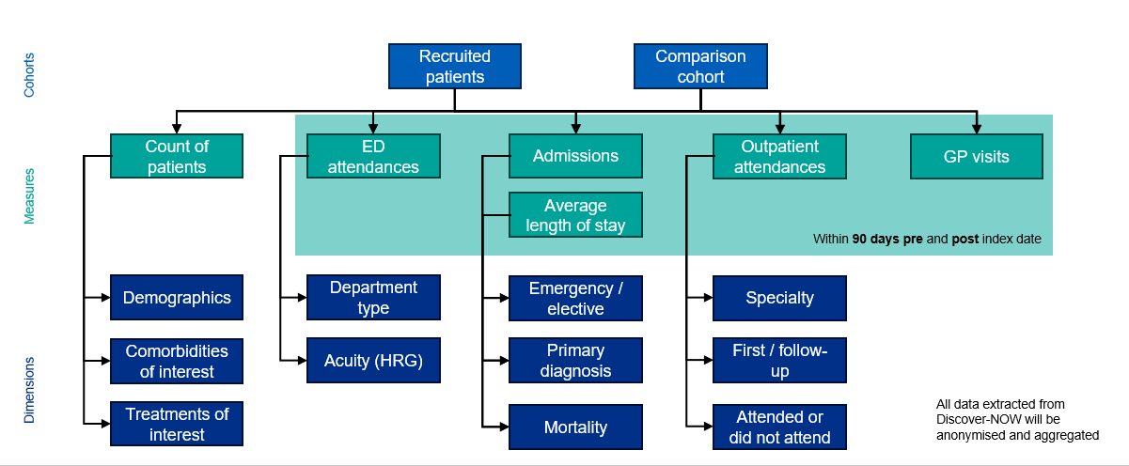

What challenges have been faced?

- Where the monies sit so we had control and access when required.
- We delayed starting the project due to length of time required to achieve full sign off for governance.
- Recruitment of staff took longer than expected due to these Board sign off processes.
- We had difficulty finding a suitable digital inclusion screening tool to measure digital literacy. Unfortunately our preferred screening tool was not open sourced so we decided to use an alternative. This we felt is the best solution, as was better received by patients due to it being shorter.
- The comparison cohort has not been statistically matched to the recruited cohort and is simply based on inclusion and exclusion criteria to best replicate the inclusion and exclusion criteria for recruitment onto the HFpEF@Home pathway. Due to this, there are potential differences in the case mix of each cohort which may create underlying differences in how patients within the different cohorts interact with healthcare services.
- Differences in activity pre- and post- index could be caused by other interventions which disproportionally affect the cohorts; therefore, these differences may not be solely attributed to the HFpEF@Home care pathway.
- The quality and accuracy of analysis is dependent on the quality of the data sources and the coding of events. Whilst every effort has been made to ensure that the quality of the data in Discover-NOW is high, it is possible that some errors in coding at data input have persisted.

Results and Impact

- There were 76 patients in the recruited cohort for HFpEF@Home pathway which data exists in Discover-NOW, with an average age of 80.4 years. 271 patients in the comparison cohort were identified through the specified inclusion and exclusion criteria, with an average age of 76.7 years.
- Morna Johnson, heart failure nurse and part of the project team successfully applied for the Horizon Fellowship which is a digital innovation fellowship delivered by CW Innovation. She completed this in July and has used the learnings from the Fellowship to enhance the delivery of the HFpEF@home project as well as showcase the project’s progress. Following on, Angela Murphy, heart failure nurse on the project team was inspired by Morna’s development that she applied for the 3rd cohort of the CW Innovation Fellowship.
- We’ve explored the use of additional developments in digital technology in healthcare and continue to work with innovation teams on areas such as screening for patients, alternative digital platforms and virtual wards.
- A reduction in A&E attendances post-index date is seen for both the recruited cohort (51% reduction) and the comparison cohort (44% reduction). The rate of A&E attendances per 100 patients is higher for the recruited cohort, both pre- and post-index.
- There is a much higher overall rate of admissions per 100 patients in the recruited cohort, and both cohorts see a reduction post-index date.
- For emergency admissions, the recruited cohort sees a 52% reduction, whereas the comparison cohort sees a smaller 35% reduction. Conversely, elective admissions see a 42% increase for the recruited cohort post-index, compared to a 38% increase for the comparison cohort. Elective admissions are likely to include ambulatory care activity.
- When specifically focusing on admissions where the primary diagnosis is heart failure, the rate of admissions per 100 patients is a lot higher for the recruited cohort pre-index.
- However, the recruited cohort sees a small overall decrease in admissions for heart failure post-index, compared to a 75% increase for the comparison cohort.
- When broken down by admissions method, emergency admissions for heart failure for the recruited cohort reduce by 72%, indicating a move away from unplanned to planned/ambulatory care following recruitment.
- Average length of stay for hospital admissions reduces from 3.3 days to 2.1 days for the recruited cohort, compared to an increase from 3.6 to 4.1 for the comparison cohort, reflecting the increase in proportion of planned care for the recruited cohort. Despite this, there is a small increase in the length of stay for emergency admissions for the recruited cohort. This appears to be offset by the increase in proportion of planned/ambulatory care which as expected has a very small length of stay.
- The large reduction in average length of stay for admissions for heart failure in the recruited cohort can be largely attributed to the higher proportion of planned/ambulatory care for this cohort. There is only a marginal change in the average length of stay for heart failure admissions in the comparison cohort.
- For heart failure emergency admissions specifically, there is a large reduction in average length of stay, which in combination with the large reduction in the number of admissions themselves shows that there is a very large reduction in bed days for this type of admission.
- Average length of stay for emergency and elective admissions for heart failure in the comparison cohort pre-index date has been suppressed due to small numbers of admissions

Survey Summary
- This survey was designed for patients living with Heart Failure with Preserved Ejection Fraction in Hounslow. The questions were developed by Imperial College Health Partners in partnership with the Cardiology Service in West Middlesex University Hospital. The survey was shared with patients as part of their onboarding process onto the HFpEF@Home project. Taking part was optional. Both a digital and paper version were offered, with most participants opting for the latter. Responses were received across a six-month period (October 2023 – March 2024). Overall, 58 responses were received.
- Management of Condition:
  - Patients feel motivated to manage their heart condition and involved in their healthcare. There is less consensus around having the right information education and support to practice self-care management (63% agree or strongly agree).
  - Hospital information materials and GPs / health practitioners are the main sources patients use for information about managing their heart condition. Support from healthcare practitioners, particularly heart failure specialist nurse support, is also considered important.
- Experiences’ of remote / virtual care:
  - A high number of participants (37%) have never received virtual / remote care. The main reason given for this was a perception that this hasn’t been offered.
  - For those who have received remote/virtual care for their heart condition telephone consultations are the most common method.
  - Experiences of remote care have been positive, however there is still a preference for in-person consultations.
- Demographics:
  - Patients who participated in the survey were from an older demographic – 72% were over 75.
  - There was a wide range in terms of how long participants had been living with their condition, from those more newly diagnosed through to those who have been living with their heart condition for several years.
  - 55% of participants have a travel time of over 30 minutes, demonstrating the potential time-saving benefits of remote / virtual care.

Focus Group
All survey participants were invited to opt-in to attend the focus group. Five patients and one carer attended. The session was delivered in West Middlesex University Hospital, a familiar and local setting to participants. The session ran for 2-hours and used open questions to explore participant’s experiences of their care. An audio recording was used to capture quotes. These have all been anonymised.
Demographics:
- Participants had lived with their condition for various lengths of time – from under 6 months to over 3 years.
- Three aged 75+ and two aged 65-74.
- All had travel times to the hospital of under 1-hour, with three less than 30 mins.
- Three identified as ‘White – British, one ‘White – Irish’ and one ‘White – Other’.
- Four male and one female

Summary results of Focus Group
Information: Point of diagnosis
- The point of diagnosis was specifically raised as an area where communication could be improved. Several participants highlighted that their diagnosis came as a shock and that they would have welcomed having an opportunity to talk to a professional about their diagnosis and what it would mean for them moving forwards. Participants were motivated to be engaged around their care, but felt they were lacking the information needed.
Information: ongoing management - Participants specifically wanted information tailored to them:
- What’s my diagnosis and what does this mean for me? Will I get better?
- How to understand blood pressure readings. When’s the best time of day to take your BP?
- What are my medications for? Will they interact with others I take? Are they forever?
- One participant raised the lack of information from their GP.
Technology: day to day
- Most participants, although not all, felt unconfident using technology and raised skill as a barrier to use.
- Younger relatives – children and grandchildren – were a source of support for people when they got stuck.
- Generally, confidence with emails was higher than confidence with apps.
Feedback on the care pathway
- All participants had received care over the phone. This approach had been well-received.
- People appreciated the convenience of being able to share their readings remotely and several participants mentioned positive changes that had been made to their medication.
- Participants felt that the calls were a good supplement to in-person, but still wanted an opportunity for longer conversations about their care.
Remote monitoring
- Participants generally felt confident taking measurements themselves at home. Some suggestions were shared around what could further improve confidence:
- Guidance on how to use machines
- Understanding how regularly machines should be checked / calibrated
- Having a healthcare professional regularly check – ideally monthly.
Technology in Healthcare
- Participants could see some benefits to being able to find reliable health information online and felt this could empower them to look up information themselves.
- However, there was clear consensus that online services and information couldn’t fully substitute the reassurance that comes from speaking to, and being seen by, a healthcare professional.
Patients Know Best
- All participants had heard of Patients Know Best but only three had used it.
- Feedback on the platform was mixed.
- Two participants raised frustration that the results shared are not lay, and are therefore of limited use.
- Another participant shared that they found it helpful to have the information to hand to share with other health professionals.
- Understanding of how the platform could be used was limited.

Quantitative Results Summary
- A&E attendance decreased by 51% in the HFpEF@Home cohort compared to 44% in the control cohort. Overall hospital admissions reduced by 4% more in the recruited cohort compared to control with emergency admissions decreasing by 17% more in the HFpEF@Home cohort post-index.
- For admissions with HF as the primary diagnosis, the HFpEF@Home cohort showed a 6% decrease post-index whereas the control cohort increased by 75%. Emergency admissions for HF in the recruited cohort decreased by 72%, mirrored by a 145% increase in elective admissions post-index.
- HFpEF@Home patients showed a reduction in LOS from 3.3 to 2.1 days compared to an increase from 3.6 to 4.1 days in the control cohort. HFpEF@Home patients admitted with a primary diagnosis of HF had a decreased LOS by 87% compared to 4% in the control.
- Comparing Outpatient appointments, there was an 18% vs 7% increase in the recruited and control cohorts respectively. The number of primary care encounters did not differ post-index (20% recruited vs 21% control), but the recruited cohort had greater engagement per 100 patients.
- Patients aged >90 had the lowest health literacy and self-reported health. Severely frail patients had worse scores across all surveys. Non-White patients had poorer scores for health status and anxiety and depression compared to White patients.

Project Conclusions
- The HFpEF@Home Care Pathway led to an overall reduction in A&E attendance and the number of emergency admissions. HF-specific admissions not only decreased in HFpEF@Home patients, but when they were admitted, their LOS was shorter representing a significant reduction in hospital burden. HFpEF@Home patients showed a shift towards elective admissions and greater engagement with primary care illustrating patient empowerment. Implementation of a HFpEF pathway has the potential to improve care for this ever-expanding patient subset.

How project findings will be disseminated
- Morna subsequently presented the updates of the project at The Burdett Trust for Nursing & C3 Collaborating for Health - NCD's Symposium which was well received.
- They were nominated for an HSJ Partnership award based on the work on Heart Failure and the collaborative working with the Innovation Patient’s Know Best. It was subsequently shortlisted and therefore a Finalist.
- Morna also presented this project using a poster at the annual Chelsea and Westminster Research, Innovation and Quality Improvement (RIQI) event (see below)
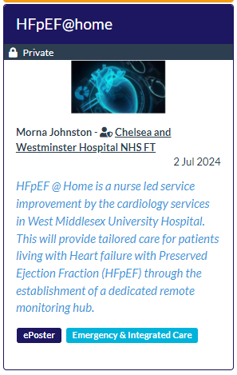
- The evaluation team started their data analysis at the beginning of February.
- The focus group took place in the summer and the information supported the evaluation of this project.
- Doccla, the virtual monitoring platform has been commissioned across the entire NWL ICS. The team will slowly transition to using this new platform.
- In terms of sustainability, we will be looking to create a business case based on the robust evaluation provided by ICHP. Recruitment on this pathway will continue beyond the expected finish date in anticipation the trust may consider commissioning this over the long term.
- An abstract of this project has been submitted to the British Society of Heart Failure.

Appendix 1
