Addressing the inequalities in respiratory health for people with learning disabilities from minoritised ethnic communities in Lancashire.

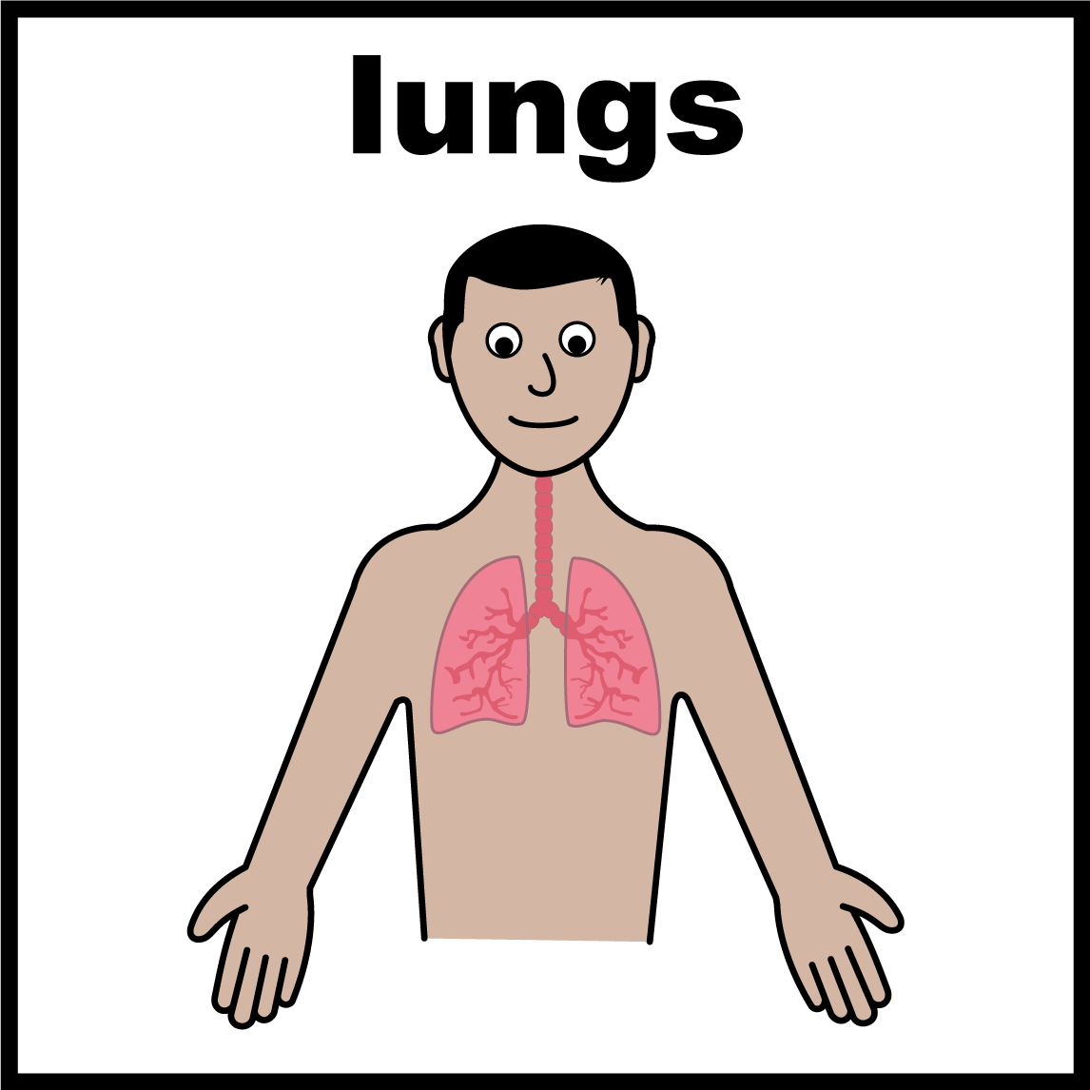

Table of Contents

Page
Grant Purpose.……………………………………………………………………… 1
Project Delivery and Timeline.….…………………………………………..…. 5
Results ……………………………………………………………………………….. 7
Challenges and Lessons Learned ……………………………………………. 10
Ongoing impact and Legacy …………………………………………………... 12
Dissemination Plans ………………………………………………………….…. 14
Recommendations ………………………………………………………………. 15
The Team ……………………………………………………………………………. 17
Appendix ……………………………………………………………………………. 18
References ……………………………………………………………………….… 20


An easy read version of this document is available on request

- Grant Purpose
To deliver a respiratory health education programme targeting Lancashire minority ethnic communities, involving delivery of co-produced workshops which focus specifically on respiratory health.
To develop a respiratory health clinical pathway, with targeted interventions for people with learning disabilities from ethnic minorities and risk of chronic respiratory disease.

Background
People with learning disabilities make up around 1%–3% of the global population (Geukes, Bröder & Latteck 2019). Learning Disability is defined as “A significantly reduced ability to understand new or complex information in learning new skills (impaired intelligence), with a reduced ability to cope independently (impaired social functioning), which started before adulthood, with a lasting effect on development” (Department of Health 2001 p.14).
Evidence strongly indicates that people with learning disabilities face substantial health disparities in comparison with people without disabilities (Bollard et al. 2018; Xu et al., 2023). This pattern is consistently highlighted in successive Learning from Lives and Deaths (LeDeR) reports (White et al 2023).
People with learning disabilities from ethnic minority backgrounds are disproportionately affected by poorer health outcomes (Emerson & Hatton, 2013; Hackett et al., 2020; Robertson et al., 2019). Alongside experiences of racial discrimination and socioeconomic challenges (NHS Race and Health Observatory (RHO), 2023; Salmi 2023), they encounter unique obstacles such as communication difficulties, limited health literacy, a lack of culturally competent and informed care within services. The interplay of race, disability, and socioeconomic status create distinct challenges and amplified disparities (Robertson et al., 2019; Roberts et al 2024), and barriers in accessing equitable and timely healthcare services are exacerbated by systemic inequalities (RHO, 2023; White et al 2023).
This inequality is highlighted in the 2022 LeDeR report (White et al., 2023), which revealed a stark contrast in life expectancy: 42% of White British individuals with a learning

disability live beyond 65 years, compared to only 7% of those from Asian British backgrounds (including Indian, Pakistani, and Bangladeshi heritage) and 5% of individuals from Black ethnic groups.
The leading cause of death within the learning disability population continues to be respiratory illnesses (Tuesdale et al., 2021). This is due to multiple factors, including poor housing, over-crowding, distrust in health services, higher rates of communicable disease, low vaccination uptake (Race and Health Observatory (RHO) 2023). A systematic review and meta-analysis undertaken by the Scottish Learning Disabilities Observatory (Truesdale et al., 2021) examined deaths linked to respiratory disease. The study revealed that individuals with learning disabilities, regardless of ethnicity, are nearly 11 times more likely to experience premature death from respiratory conditions compared to those without learning disabilities.
With the release of the ‘We Deserve Better’ report (RHO 2023) the team recognised the need to establish a project which aims and to support the early recognition and identification of respiratory ill health in the learning disability population from ethnic minority backgrounds in Lancashire. The project is to deliver a respiratory health education programme targeting Lancashire minority ethnic communities, involving delivery of co-produced workshops which focus specifically on respiratory health. In addition, a respiratory health clinical pathway, with targeted interventions for people with learning disabilities from ethnic minorities and risk of chronic respiratory disease will be developed.

2. Project Delivery and Timeline
The Healthy Lungs project began in April 2024 and concluded in July 2025, spanning 16 months of intensive planning, community engagement, delivery, and reflection. The project followed a phased approach, beginning with team formation and partnership development, moving through workshop co-design and delivery, and culminating in data analysis and dissemination of findings.

Phase 1: Foundation and Engagement (April–September 2024)
The initial months focused on recruiting the project team and establishing an advisory board made up of health professionals, academics, community representatives, and people with lived experience. We also began proactive community engagement, connecting with local mosques, carers’ groups, charities, and self-advocacy networks. Informal events - such as coffee mornings - proved crucial in building trust and shaping a culturally sensitive approach.

Phase 2: Co-Production and Design (October – November 2024)
Workshop content was co-designed during this period, drawing on clinical expertise and lived experience. Input from families, carers, and community partners, through focus group and workshop ‘dress rehearsals’ helped ensure materials were accessible, culturally relevant, and inclusive. We refined content iteratively, adapting visual aids and integrating feedback on session structure and delivery style.

Phase 3: Delivery and Data Collection (December 2024 – July 2025)
Over the winter months, we delivered the workshops, collecting both pre- and post-session data to assess impact. The pace of delivery of the workshops ‘took off’ during spring 2025 with recruitment to the team of learning disability nurses with backgrounds in Health Facilitation. Sessions were delivered in community-based settings, special schools, with learning disability providers and day services and involved interpreters where needed. Alternative feedback methods—like video interviews and visual satisfaction tools—were introduced to ensure accessibility.

Phase 4: Analysis and Dissemination (April – July 2025)
We completed data analysis and compiled the findings for presentation and dissemination. Insights were shared at key events, including the ICCHNR and CANDDID conferences, and are informing wider practice across the region. A summary report, easy-read resources, and a toolkit for professionals were developed to support sustained impact.

Notable Partnerships and Collaborations
The success of the project was underpinned by strong collaborations with organisations such as Blackburn with Darwen Carers, Learning Disability Partnership Boards, Primary Care Networks, Paradise Gems, Purple Patch, and local mosques and faith leaders. We also partnered with Bradford District Care NHS Foundation Trust, aligning our work with their “Keeping My Chest Healthy” initiative. These partnerships enabled co-production, facilitated trust within communities, and are continuing to influence health delivery models beyond the life of the project.

 | Task | April to July 2024 | Sept | Oct | Nov | Dec | Jan | Feb | March | April | May | June | July
1 | Establish/recruit project team
 | Establish advisory board
 | Engagement with local communities, and key stakeholders - coffee mornings, attend events, order resources, promote and engage
1 | Design and refine workshop content
5 | Socialise workshops invite attendees
6 | Deliver workshops
7 | Gather pre & post workshop data
8 | Analyse data
9 | Present findings

3. Results
Over the course of the project, we delivered 26 co-produced workshops, reaching 379 attendees, including people with learning disabilities, families, and carers. Beyond these sessions, our reach extended significantly through active participation in Health Melas, Speak Up events, community radio, mosques, and nursing conferences - engaging hundreds more across diverse community and professional settings. These activities have helped raise vital awareness around respiratory health and self-care in culturally meaningful ways.

Our easy-read and culturally relevant resources have been widely disseminated across Lancashire and South Cumbria, and have featured at regional, national, and international conferences. They continue to support inclusive education and engagement across the health system. In parallel, we are developing a toolkit to support other Trusts and services in adopting and replicating this approach.
As part of the “Keeping My Chest Healthy” pathway pilot, 12 individuals with learning disabilities have accessed newly established multidisciplinary respiratory clinics, marking an important step toward more inclusive and proactive respiratory care for people with learning disabilities.
See Appendix 1 for evaluations/feedback

What We Heard: Reflections from Families and Carers

Learning Together, Listening Deeply
“I found out about the sessions through word of mouth,” shared one parent. “At first, I wasn’t sure what to expect. But the moment I stepped in, it felt like a respectful space – people listened, and no one talked over each other.”
Over the course of the project, families and carers attending the Blackburn with Darwen Asian Carers Group shared how much the sessions meant to them. They valued the opportunity to learn new things in an environment that felt safe, respectful, and welcoming.

“Felt like a comfortable and respectful environment.”
“Created a respectful and safe space, the group dynamic was good as people listened and didn’t speak over each other.”
“Taught us things we had never heard about before in relation to keeping our lungs healthy – like sitting up straight.”
“Useful for me – my son has autism and LD and I found it really useful, especially in relation to constipation.”

Time to Connect, Time to Reflect
The balance of structure and social time was important to the group. Families appreciated a space where they could learn, share, and connect informally – often over coffee and cake.
“Concentrate on a weekly topic – 2 hours per session, with time to talk in between and coffee and cake.”
“Face-to-face is great, as long as it allows time for the social aspect.”
There was also constructive feedback about logistics, particularly around session length and the use of interpreters.
“Prefer shorter sessions – learning from last sessions with interpreter which took a lot longer.”
“Sessions were a little long, but the resources were good and have been kept to refer back to.”
Importantly, there was a strong desire to continue:
“Would like to keep in touch and have future sessions.”

Spotlight: A Parent’s Journey – From Frustration to Relief
One mum, a parent of a young person with learning disabilities and autism, attended the sessions through the Asian Carers group at Blackburn Carers Centre. She had long been seeking support for her child’s ongoing health issue – severe constipation and breathing problems – but with little success:

“I had been to the doctors many times, but something still felt wrong. Because my child is non-verbal, it’s hard to know when something’s bothering them.”
During one of the sessions, the mum connected with Courtney and explained the issue. Through open conversation and easy-to-understand information, she learned that severe constipation can sometimes cause or worsen breathing problems due to increased abdominal pressure on the diaphragm, and that stopping and starting the medication could be part of the problem, and that consistent use was key – something that hadn’t been fully explained to her before.
“Courtney took the time to explain it clearly. At the doctors, I always felt under pressure – rushed. This session gave me time to understand.”
With this new knowledge, the mum shared the information with her husband and extended family. Together, they began using the medication more consistently – and saw immediate improvement in their child’s condition.
“It’s made a huge difference. The issue is greatly improved now, and we’re so grateful.”
This story is just one example of the meaningful, practical outcomes that emerged from the sessions – combining professional expertise with trust, empathy, and the time and space to ask questions.

4. Challenges and Lessons Learned
Delivering a project focused on addressing respiratory health inequalities among people with learning disabilities from minoritised ethnic communities inevitably brought challenges. However, through strong partnerships, adaptability, and reflection, we were able to overcome many barriers and gain valuable insights for future work.
Community and professional engagement presented very different experiences. Local charities, carers’ organisations, self-advocacy groups, special schools, mosques, and community leaders were overwhelmingly welcoming and appreciative of the support offered. In many cases, they expressed that they had not previously been invited to participate in health-related work tailored to the needs of their communities. Language barriers were an early hurdle, but these were mitigated through the use of a consistent interpreter who became a trusted and valued stakeholder. Additionally, friends, relatives, and community volunteers stepped in to interpret and support, creating a shared sense of purpose and trust.
Engaging with health professionals, however, was significantly more difficult. Some primary care teams, including GP practices, learning disability champions, respiratory teams, and special school nurses, often lacked capacity to engage, driven largely by staffing vacancies and service pressures. In some instances, having a Learning Disability was cited as an exclusion criterion for certain services, highlighting a deeper systemic issue. This underlined the urgent need for awareness-raising and education among health professionals regarding the importance of accessible, inclusive respiratory care for this population.
An ongoing and future challenge to engagement is the cost associated with organising community events. Providing food and drinks was recognised as a key factor in encouraging attendance and creating a welcoming, culturally appropriate environment. While this was achievable during the Healthy Lungs project due to available funding, sustaining this practice may prove difficult for some organisations in the future, particularly in the current climate of financial constraint.
Data collection and stakeholder engagement also required adaptation. Many partner organisations and community groups were willing to support data collection, but we encountered difficulties when it came to evaluating the impact of the workshops. Traditional easy-read questionnaires proved too complex for some attendees, prompting us to innovate. We introduced creative, accessible methods such as colour-coded balls and buckets for participants to indicate their satisfaction, and video-recorded participant reflections, which provided richer, more meaningful feedback. This flexibility in approach was crucial to ensuring we captured authentic voices.
Key lessons emerged throughout the project. One of the most significant was a realisation of the deep-rooted systemic health inequalities experienced by this population. Many individuals and their families reported having no voice and little recognition in mainstream health conversations. In some languages, there isn’t even a direct term for “Learning Disability,” which further marginalises the group and hinders service design and outreach. The ‘We Deserve Better’ report was instrumental in shaping our awareness of these inequalities and helped ground the project’s purpose.
We also made meaningful adaptations to our delivery. Feedback from participants helped us evolve our workshop content and delivery style. All team members undertook cultural sensitivity training, and we made deliberate efforts to adapt content to suit different cultural contexts - this included modifying the healthy eating plate to reflect diets familiar to minoritised ethnic groups and delivering adapted sessions directly in locations to reach underserved community members in trusted settings.
Recruitment posed additional challenges. We underestimated the time and effort it would take to recruit someone to work within communities they were unfamiliar with. Ideally, we would have recruited someone with strong existing local connections. Once we partnered with community Learning Disability nurses who had a background in health facilitation, engagement improved significantly.
In overcoming these challenges, the project became more rooted in co-production, responsiveness, and cultural competence - lessons we will carry forward.

5. Ongoing Impact and Legacy
One of the most powerful outcomes of this project has been its ability to generate lasting impact and momentum, both within Lancashire and beyond. Through our work, we have established meaningful and sustained partnerships with a range of charities and community groups - including Paradise Gems, Purple Patch, and Blackburn with Darwen Carers - who continue to collaborate with the Health Facilitation Team. These partnerships have created a stronger, more connected support network for people with learning disabilities from minoritised ethnic backgrounds and will remain central to our future focus.
Our engagement with local Mosques and faith leaders also laid the foundation for a more culturally sensitive and inclusive approach to health education. This area of work will be a key ongoing priority for the Health Facilitation Team, ensuring that respiratory health continues to be addressed in settings and formats that are trusted and accessible for underserved communities.
The project has also helped raise the profile of health inequalities experienced by people with learning disabilities from ethnic minority backgrounds on a national and international stage. We presented our work at both the International Collaboration for Community Health Nursing Research (ICCHNR) and the CANDDID conference, where it was well received. Being shortlisted for an HSJ Patient Safety Award further validated the importance and innovation of the work, generating significant interest from health and social care professionals seeking to replicate our approach.
We have also formed a valuable collaboration with Bradford District Care NHS Foundation Trust and their "Keeping My Chest Healthy" initiative. As early adopters of their respiratory pathway pilot, we were able to align our work and contribute real-world learning, as well as developing a respiratory sub pathway as part of the All-Age Learning Disability Service Physical Health Model of Care. Members of their team attended our workshops, and they have begun adapting our approaches within their own localities.
Importantly, the project’s resources and tools will continue to benefit the wider community. Our suite of easy-read materials on respiratory health - covering healthy lungs, how to spot early warning signs, and how to prevent respiratory illness - will remain available via the Health Facilitation Team’s website and will be used in ongoing outreach and education.

Finally, the approach we developed through this project is now being embedded as standard practice across Lancashire and South Cumbria. The Health Facilitation Team is committed to continuing and expanding this work, ensuring that inclusive, culturally appropriate respiratory health support becomes a core part of how services are delivered in the region.

6. Dissemination Plans
Dissemination of our project findings is already well underway. We have actively shared our work at national conferences, ensuring early engagement with practitioners, academics, and policy stakeholders. A key forthcoming opportunity is our participation in the Burdett Trust’s Chronic Respiratory Diseases Symposium, where we will present our outcomes and learnings alongside other funded projects. This collaborative platform will allow for mutual learning and wider visibility within the specialist respiratory care and nursing community.
We are also planning a range of dissemination activities to extend the project’s reach. These include the development of a practical toolkit and summary report aimed at healthcare professionals working with people with learning disabilities and respiratory conditions. Additionally, we are exploring the production of short videos to share key insights and lived experiences, making the content accessible to a broader audience.
As part of our future research strategy, we have commenced a proposal to explore whether a targeted respiratory education programme can reduce health inequalities for people with learning disabilities from minoritised ethnic communities. The outcomes of this research will be submitted for publication in an academic journal, contributing to the evidence base on health equity and inclusive respiratory care.
Finally, as finalists in the 2025 HSJ Awards – Learning Disabilities Innovation of the Year category – we anticipate significant national interest in our work. This recognition will further support dissemination efforts, enabling us to reach policy makers, service providers, and frontline clinicians across the UK.

7. Recommendations
Based on the insights and outcomes of the Healthy Lungs project, we propose the following recommendations to guide other organisations, systems, and stakeholders seeking to address respiratory health inequalities among people with learning disabilities from minoritised ethnic communities. These recommendations reflect the practical learning gained through community collaboration, workshop delivery, and cross-sector partnerships.
A. Recommendations for Integrated Care Boards (ICBs), NHS Trusts, and Primary Care Networks (PCNs)
- Embed, with experts with experience, co-produced education initiatives
- Replicate culturally tailored, co-designed respiratory health workshops as a core component of health prevention and education for people with learning disabilities
- Develop inclusive respiratory pathways
- Build upon models like the Bradford District Care NHS Foundation Trust "Keeping My Chest Healthy" initiative to create clinical pathways that identify and support at-risk individuals early, with appropriate follow-up and multidisciplinary input
- Expand health facilitation capacity
- Employ Learning Disability Nurses with experience in Health Facilitation to improve care navigation, reduce exclusion, and embed best practice within community and primary care settings
- Prioritise accessible communication
- Use and promote easy-read resources, visual aids, interpreter support, and alternative feedback tools (e.g. video or visual response methods) to enhance accessibility and engagement
- Challenge exclusion in service access
- Commit to cultural competence - Deliver ongoing cultural competence and unconscious bias training across clinical and frontline teams, with particular attention to the intersection of disability, ethnicity, and socioeconomic factors.

B. Recommendations for National Policy Makers and System Leaders
- Mandate inclusive health standards
- Establish national expectations for the routine inclusion of people with learning disabilities from minoritised communities in respiratory and preventative health strategies.
- Fund sustainable community-led health promotion
- Provide dedicated funding for NHS - community partnerships that co-design and deliver culturally competent health education in trusted settings such as faith groups and carers' networks.
- Standardise data collection for accessibility
- Support the development of inclusive data-gathering tools and outcome measures to ensure accurate evaluation of impact in populations with communication and cognitive differences.

C. Recommendations for Future Research
- Evaluate long-term health outcomes
- Investigate whether culturally inclusive respiratory education reduces respiratory-related hospital admissions, improves health literacy, or improves quality of life over time.
- Conduct further research into the barriers that prevent equitable access to respiratory and preventative healthcare for people with learning disabilities.
- Adapt the model for other conditions - Extend this inclusive, co-produced model to other long-term health conditions—such as diabetes, cardiovascular health, or mental health - particularly in underserved communities.

Tracey Hartley-Smith Esther Smith
Consultant for Children and Young People Advanced Clinical Practitioner
People with a learning disability Learning Disabilities Services Pennine

Courtney Fisher Michelle Thornton Sahid Mohamed
Community Learning Project Administrator/ Peer Support Worker
Disability Nurse Lived Experience Coordinator

Meghan Ewing Joann Flannigan Crystal Small
Health Facilitation Health Facilitation Health Facilitation
Community Learning Community Learning Community Learning
Disability Nurse Disability Nurse Disability Nurse

The Healthy Lungs Project Team
Lancashire and south Cumbria NHS Foundation Trust

Appendix 1

Appendix 1
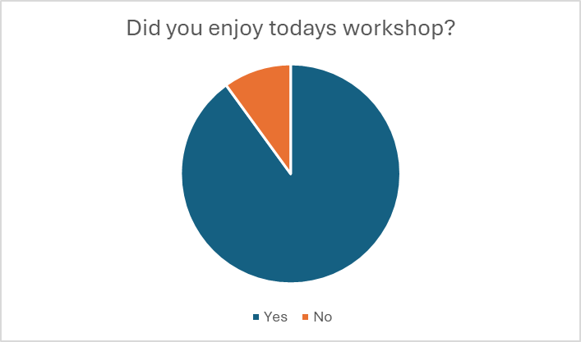

References

BOLLARD, M., McLEOD, E. and DOLAN, A. (2018) Exploring the impact of health inequalities on the health of adults with intellectual disability from their perspective. Disability & Society, 33(6), pp. 831–848. Available at: (accessed October 12 2024) https://doi.org/10.1080/09687599.2018.1459476

DEPARTMENT OF HEALTH (2001) Valuing People: A New Strategy for Learning Disability for the 21st Century A White Paper 5086.pdf (accessed November 1 2024)

EMERSON, E., HATTON, C. 2013 Health Inequalities and People with Intellectual Disabilities. Cambridge University Press 2013 Online ISBN: 9781139192484 DOI: https://doi.org/10.1017/CBO9781139192484 (accessed November 5 2024)

GEUKES C, BRODER J, LATTECK ÄD. 2019 Health Literacy and People with Intellectual Disabilities: What We Know, What We Do Not Know, and What We Need: A Theoretical Discourse. International Journal Environment Res Public Health. 2019 Feb 5;16(3):463. doi: 10.3390/ijerph16030463. PMID: 30764539; PMCID: PMC6388359. (accessed November 5 2024)

RACE AND HEALTH OBSERVATORY 2023 We Deserve Better; Ethnic Minorities with a Learning Disability and Access to Healthcare. https://www.nhsrho.org/wp-content/uploads/2023/05/Part-A-RHO-LD-Policy-Data-Review-Report.pdf (accessed October 23 2024)

ROBERTS, C., DITZEL, N., COOPER-MOSS, N., UMBLEBY, K., CHAUHAN, U. 2024 Culturally adaptive healthcare for people with a learning disability from an ethnic minority background: A qualitative synthesis. British Journal of Learning Disabilities 2024 p1-11. DOI: 10.1111/bld.12614 (accessed October 10 2024)

ROBERTSON, J, BEYER S, EMERSON, E, BAINES, S, HATTON, C. 2019 The association between employment and the health of people with intellectual disabilities: A systematic review. Journal of Applied Research Intellectual Disabilities. 2019 Nov;32(6):1335-1348. doi: 10.1111/jar.12632. Epub 2019 Jun 10. PMID: 31180175. (accessed October 10 2024)

SALMI, D,. 2023 People with learning disabilities can face double discrimination. Learning Disability Practice 26(3):12-14 2023 1465-871210.7748/ldp.26.3.12.s4 (accessed November 16 2024)

TRUESDALE, M, MELVILLE, C, BARLOW F. 2021. Respiratory-associated deaths in people with intellectual disabilities: a systematic review and meta-analysis. British Medical Journal Open 2021;11:e043658. doi:10.1136/bmjopen-2020-043658 (accessed October 10 2024)

WHITE, A; SHEEHAN, R; DING, J; ROBERTS, C; MAGILL, N; KEAGAN-BULL, R; CARTER, B; CHAUHAN, U; TUFFREY-WIJNE, I; STRYDOM, A; 2023 Learning from Lives and Deaths - People with a learning disability and autistic people (LeDeR) report for 2022. LeDeR Autism and learning disability partnership, King's College London (accessed October 11 2024)

XU, Y. et al. 2023 Racial and Ethnic Disparities in Chronic Disease Outcomes Among Adults with Intellectual and Developmental Disabilities. Journal of Developmental and Physical Disabilities, 36(3), pp. 557–574. Available at: https://doi.org/10.1007/s10882-023-09923-7. (accessed November 16 2024)

