Project Report

Project Summary

A Respiratory Outreach Project to target children and young people who are accessing acute care for asthma or not being seen in traditional planned care settings.

Summary of Grant Proposal

Sadly, asthma continues to claim lives among children and young people (CYP) and our community is not exempt from this.

The National Child Mortality Database report, published in December 2024, documents that between April 2019 and March 2023 there were 54 deaths caused by asthma. 65% of the CYP who died had attended Accident and Emergency, or had a hospital admission, in the 12 months prior to their death and 87% had been issued with three or more reliever inhalers in the same period, both indicators of poor asthma control.

North East and North Cumbria (NENC) ICB data, from September 2023 to August 2024, also highlights that 33.2% of CYP had not had an asthma review as part of their access to traditional primary care provision. Our project aims reflected a need for improvement in asthma care for local CYP.

The proposal was to improve patient access to asthma care for CYP in our locality by focusing on patients who were not accessing care in traditional planned settings, namely General Practice. Providing care in convenient community-based settings and focusing on the inequalities that are faced by patients, we aimed to increase patient engagement with nurse-led long-term condition reviews.

Because asthma is a reversable condition, our ultimate goal was for the patients we saw to be symptom free and to live with increased wellbeing, without the restrictions that poorly controlled asthma can have on normal activities. We knew that this goal would be best served by promoting a multi-professional approach, so we wanted to link families with Personalised Care Teams and inspire nurses to champion ongoing excellence in asthma care within General Practice, by allowing them to work in a different way.

Reviewing data helped us to gain a better understanding of health inequalities to focus on groups of patients that might need a different approach. We planned to use coded entries in medical records to measure the impact of the project. Improved Asthma Control Test (ACT) scores and increased numbers of eligible children having a Personal Asthma Action Plan (PAAP) in place would be a key measure of quality. We had ambitions that the use of acute hospital services due to asthma exacerbations would be reduced to prove the projects positive impact on our local population.

Alongside improving outcomes for children, we aimed to expand the skill sets of our local nurses, increasing their confidence and enhancing their autonomy. We hoped that participating in the project would improve their knowledge and motivate them to champion excellence in asthma care in their own practices in the long-term.

What Activities have Taken Place?

In partnership with local voluntary sector organisations, we shared insights about the community to identify appropriate hubs for our project. We prioritised accessibility for asthma reviews, offering appointments either early in the morning or after school. Flexibility was key, so we were understanding if children were slightly late, ensuring access was as easy as possible. Since poorly controlled asthma can often affect the education of CYP, providing out-of-school-hours services through this project was important.

We also offered appointments from a GP Surgery location on some Saturday mornings. These sessions proved popular with working parents and, although this sometimes meant a longer journey to the appointment, it was more convenient for them. The sessions were well attended and enabled holistic support for families who had additional social care needs, as the Personalised Care Team were often on site too.

The next phase of the project moved to focus on opportunities for reviews to take place in schools. I worked hard to build relationships with the 0-19 healthcare team and other contacts who we considered may be able to help us move the idea forward. The investment of time paid off and I was able to forge a strong alliance with a member of the school team who also felt passionately about making this work.

Conducting asthma reviews in the school setting enabled further improved access to healthcare for patients and allowed an opportunity to educate the wider school team about the importance of CYP having annual asthma reviews.

As we advanced with the clinical delivery of the project, we successfully achieved our goal of expanding our reach beyond Stockton PCN. We offered out-of-hours appointments at General Practice sites across Stockton and Hartlepool, which were accessible to patients from other PCNs in the area, again helping to improve access and reduce variation across the PCNs.

Raising public awareness at local events has enabled us to connect with parents to emphasise the importance of having an annual asthma review. The 'All Together for You' events, held at local family hubs, bring together representatives from both social and healthcare organisations. These events provided an opportunity for us to book patients into our clinics on the spot.

The 'Going for Gold' event, hosted by Stockton Borough Council on Stockton High Street during the summer, gave us another chance to promote health. This event led to valuable conversations with both adults and CYP about asthma and other respiratory topics, such as smoking and vaping. The display of inhaler devices and model airways attracted attention and sparked discussions, helping to improve patient engagement with healthcare services.

Our latest social engagement involved the team providing education from the RALPH Bus, a mobile research and health vehicle, at the local weekly market. This space helped provide a fully immersive respiratory resource. We worked in collaboration with the local smoking cessation team to allow respiratory health needs to be addressed holistically at the same point of contact.
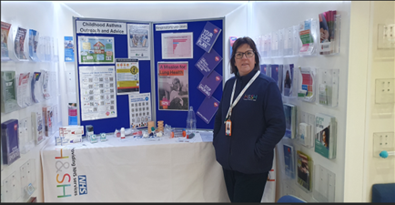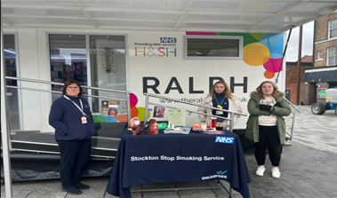

What Challenges have been Faced?

We quickly learned that a project such as this relies heavily on accurate coding in the patient records and sensitive search programmes. We had anticipated that searching clinical systems to find the patients for review would be straightforward. Unfortunately, on checking a selection of patient notes at random, it became apparent that in some cases the patients identified might not be the right ones for our project.

For example, a search that looks for apparent poor control of asthma by identifying patients who have been given an acute prescription for rescue dose oral steroids, might identify a child who has severe eczema instead. Searches had to be adapted to meet the needs of the projec. Discrepancies in the data showing the number of reviews undertaken compared with the total number of appointments used may have resulted from these coding issues.

The project has also highlighted issues faced in General Practice and the pressures that are felt in relation to staffing and workload. We wanted nurses from General Practice to be involved, to allow for professional development, because both across the PCN and in general, nurses seeing patients for asthma reviews report feeling less confident about managing CYP. We hoped that this project would help improve this. To this end, we held meetings with nurses to explain the aims of the project early on and this resulted in a number of expressions of interest. Nurses appreciated the need for a different approach to care provision that would help to address inequalities, but their ability to participate was, in some instances, hindered by pressures and different priorities in practice.

Gathering patient feedback about the impact of the project has also proved challenging. We used a digital system to try and gather opinions, which resulted in a small number of responses. The delay in requesting the feedback may have contributed to the lack of response rate and, on reflection, we believe that sending the request immediately after the appointment may have improved this. It may even be beneficial for the nurse to ask parents to complete a written feedback form at the end of the review in future projects.

Both suggestions would create a larger response, which means that we would have more opinions on which to base future plans. Incorporating multiple formats to gather a wider representation of feedback would also be beneficial.

The project attempted to incorporate the use of digital technology to aid patients' self-management of asthma. We drew on experience from other work, particularly the use of pulse oximetry at home during the COVID pandemic. Technology had proved essential at that time, making it possible for patients to feel reassured by providing their vital signs to healthcare professionals for monitoring.

We intended to incorporate the 'MyAsthma' app and 'Smart Rescue' devices in this project, where the clinician felt there was potential benefit to the patient. The uptake of both types of innovation was low, which had not been anticipated when we designed the project. This may have been a result of lack of understanding of the benefits of the technology.

We also quickly realised that the 'Smart Rescue' device only had a small scope of potential impact. The device is designed to help reduce overuse of metered dose inhaler medications (MDIs), traditionally 'relievers', and as local and national guidelines regarding the management of asthma have recently moved away from MDIs towards more environmentally friendly dry powder inhalers (DPIs), the 'Smart Rescue' device has a limited impact for our patient group.

The 'MyAsthma' app initially sparked interest from both patients and their parents, particularly those in the secondary school age group. Many agreed the app could assist in better managing asthma and, as a result, I enrolled several patients. Despite dedicating time to personally support patients in accessing the app, activation rates remained low.

While the reasons behind the lack of sustained engagement post-enrolment remain unclear, it is likely that patients do not fully appreciate the benefits of self-management during symptom-free periods. This contrasts with findings from a previous project involving pulse oximetry, where patient engagement appeared higher due to the immediate, tangible feedback provided by the tool during an episode of acute illness.

Another challenge was finding suitable locations to allow for equitable access for all. The use of patients' home postcodes was initially helpful, when planning the PCN project. The locations that we used were impacted by the availability of rooms and the uptake of appointments by patients at each site. Data showed that the locations most frequently used were Redhill Family Hub and Woodbridge Medical Practice (evening and weekend clinics). As the project progressed, we learned and adapted as we went along, especially with reference to location.

Patients who took the time to give formal feedback all suggested that it was helpful having an appointment in a community location or at the practice out of hours. This would support any plans for future provision.

Results and Impact

We reviewed 111 patients from 16 practices across 9 community locations (see Appendix).

Long-term data on the project's impact is not yet available. Metrics such as acute A&E attendances and reliever inhaler use remain undetermined, and these broader outcomes can be assessed at a later stage. We look forward to reviewing this and seeing if there has been any longer-term impact for these children.

The outcomes that are measurable after 12 months show an overall positive impact of the project. This includes key performance indicators which were highlighted in the grant proposal to enable us to demonstrate the project's outcomes.

The number of patients who do not attend appointments is a concern in many services and one which bears reflection. To try to avoid wasted appointments, we decided that the booking process would be best delivered with a personal approach. Therefore, a member of our administration team booked all appointments over the telephone. This allowed for a full explanation of the project, which we hoped would raise engagement. If this method of contact was unsuccessful, electronic booking systems were also used and, regardless of the method of contact, all patients were sent text message reminders prior to the day of the appointment.

If the patient did not attend the appointment, the nurse attempted to make contact on the telephone. Ideally, this would result in the face-to-face appointment being rebooked, but a telephone review could be undertaken, if there was no clinical concern which warranted a face-to-face review as a priority. Overall, 85% of our offered appointments were booked and 75% of the booked appointments were attended. Further understanding of the reasons for non-attendance would be helpful for future projects.

The number of patient reviews is a reassuring, positive outcome from the project, as these CYP may not have been seen and reviewed without this. I noticed that several CYP seen were those who had "fallen off the radar" since their initial visit to General Practice for symptom investigation. The COVID pandemic led to some children being lost without follow-up and this valuable work helped to reconnect with them, ensure they have been reviewed, and bring them "back into the system".

Additionally, CYP who had not completed the diagnostic process in practice were often using inhaled medications, but had not been called for their annual review, as their diagnosis had not yet been coded. This meant that they also had not received a PAAP. The absence of a PAAP could lead to inappropriate self-management if their condition were to worsen. Recognising the value of having a written asthma plan, all 111 CYP seen by our clinicians received one.

Reflecting on patient outcomes throughout this project has enabled us to begin establishing a network of nurses to serve as respiratory champions across our local Primary Care Networks. Inspiring and enhancing confidence in respiratory practice in this dedicated group of nurse advocates will be an essential legacy from the project.

I asked the nurses who were involved in the project to complete a questionnaire, so that we could understand the difference in their clinical confidence from the beginning to the end of the project. Initially, their main concern was a lack of experience in working in settings other than General Practice. An example of improved levels of confidence at the end of the project is demonstrated here:

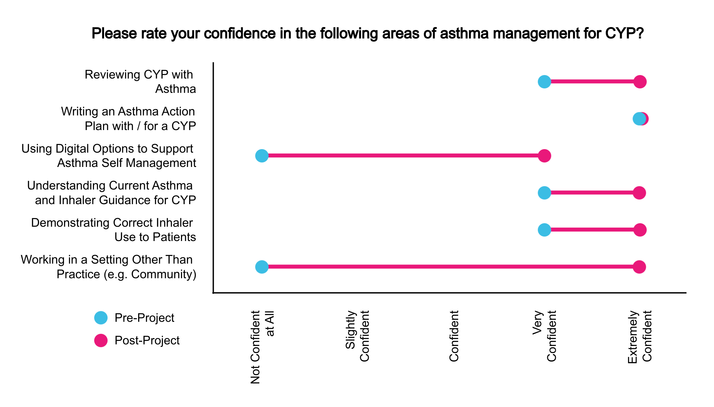
Figure 1 : Sample Confidence Data

A nurse took the time to reflect on their experience and reported feeling satisfied that they had made a big difference for the patients who attended for review. Appointment length played a part in this satisfaction as this was increased from usual review appointment times in General Practice. This was felt to enhance the experience for everyone.

Access to all necessary clinical equipment for this project ensured that we were able to provide a gold standard review for patients at all sessions, which was paramount to achieving our aims. The project allowed us to have equipment at all sites, so whichever location the session was being held at the equipment was always available.

Access to a FeNO machine is not always possible in General Practice settings, but as part of this project was invaluable to provide an in-depth, evidence-based review to empower patients and their parents to understand and self-manage their condition.

From those parents that did respond to a feedback request there were positive comments and all suggested that they would appreciate an ongoing provision of asthma review appointments in community settings, schools, and weekend appointments at General Practice sites. These comments included:
“

I was very happy with this service, I was due to also attend but unable to at short notice, but the nurse called me after my daughters review and discussed everything that she had gone through with my daughter. Both myself and my daughter thought the nurse herself was lovely and she explained everything clearly.

“

The implementation of this service I found beneficial with a professional whom can talk on a level with a teenager. Added to the care closer to home mandate this is an excellent example of this – given the demands on school attendances.

“

I hope this continues moving forward for all children especially those with long term medical conditions. I hope the funding continues.

How Project Findings will be Disseminated

Results will be shared with… | Why?
Nurses involved in the project | For professional development  To allow reflection  To further inspire them to take a more prominent role in practice  To inspire nurses to become a 'respiratory champion' and positively affect processes in General Practice
Other healthcare professionals  (via poster presentations at future respiratory conferences) | To share findings with professionals from other localities and inspire improvements in regional models of care
PCNs across Hartlepool and Stockton | To inspire and empower practices to adopt prioritisation tools, which are available to support clinicians to manage workloads in improved ways
CYP services and public health service teams in the locality | To support the effective implementation of the asthma bundle of care in our locality by promoting provision of a sustainable ongoing community-based asthma review programme
Clinical Directors, ICB Primary Care Leads, ICB Medical Director and local hospital teams | To inspire onward commissioning of a community-based asthma service provision and promote integrated working.

Since the completion of this project summary, I am delighted to share with you that I have submitted a summary abstract of the project, and this has been accepted for oral presentation at The Association of Respiratory Nurses Conference to be held in May of this year.

Appendix – Project Data

Identifying Patients
161
patients were identified via the searches from across the PCN’s.
There were 18 patients who were identified within the initial search that were under the age of 5. A clinical decision was made that these 18 patients would be triaged back to practices with appropriate advice, guidelines and support.
This left 143 patients to be contacted about the Children's Asthma Clinics.
111 patients successfully engaged within the service.
Within this project 77.6% of the total 143 were seen.

SystmOne Data

Rota Type | Appointments Offered | Unused Appointments | Booked Appointments | DNAs | Appointments Delivered
Chadwick Practice | 17 | 2 | 15 | 3 | 12
Eaglescliffe Medical Practice (EMP) | 19 | 0 | 19 | 4 | 15
Norton Medical Centre | 8 | 2 | 6 | 2 | 4
Redhill Family Hub, Roseworth | 63 | 12 | 51 | 17 | 34
The Youthy, Thornaby | 18 | 8 | 10 | 3 | 7
Thornaby Family Hub, Tedder Avenue | 37 | 0 | 37 | 12 | 25
Woodbridge Medical Practice | 50 | 11 | 39 | 10 | 29
School Hubs | 23 | 0 | 23 | 0 | 23
Harewood Primary School | 2 | 0 | 2 | 0 | 2
Ingleby Manor School | 21 | 0 | 21 | 0 | 21
Total | 235 | 35 | 200 | 51 | 149

Patient Demographics

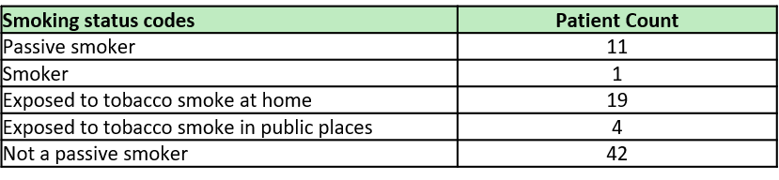
Review Outcomes
ACT Readings

(79.2%) 88 patients out of 111 had an ACT score recorded.
15% patients had a follow up review of their ACT score due to clinical concerns.
From the 15% of patients, they all had improvements in their scores. The increase amongst the 17 patients was an average of +53.8%
The highest increase in difference between the 1st ACT score and the review was an increase of 13.
22 Patients had 6 or more prescriptions of SABA over the last 12 months prior to being seen at the Childrens Asthma Clinic.
Which is 19.8% of all patients seen.
The highest prescription amount was 24 for a single patient.
8 patients' parents/guardians and 1 patient received smoking cessation advice
(100%) 111 patients have received a Personal action plan or had one reviewed within the clinic.
(47.7%) 53 patients out of 111 had a Personal action plan which was more than 18 months out of date before receiving one at their appointment
Peak Flow Readings
(90%) 100 out of 111 patients had a Peak flow reading.
51 patients had a code of ‘child not brought’ but via a telephone follow up by the nursing team the patient still had a successfully finished appointment.
18 patients had a code of ‘Failed encounter’ which means the patient did not attend but also was not contactable after the appointment for a telephone alternative. A voicemail was left in this case.
93 appointments patients had a code of ‘F2F appointment’.
44 appointments had a code of ‘Telephone appointment’.
38 patients have had a Follow-up appointment
84% Appointments booked
63% Overall utilisation

SABA = Short-acting beta-agonist | ACT = Asthma Control test

Accessed at https://www.ncmd.info/wp-content/uploads/2024/12/Asthma-and-anaphylaxis.pdf
Accessed at https://www.england.nhs.uk/publication/national-bundle-of-care-for-children-and-young-people-with-asthma/

